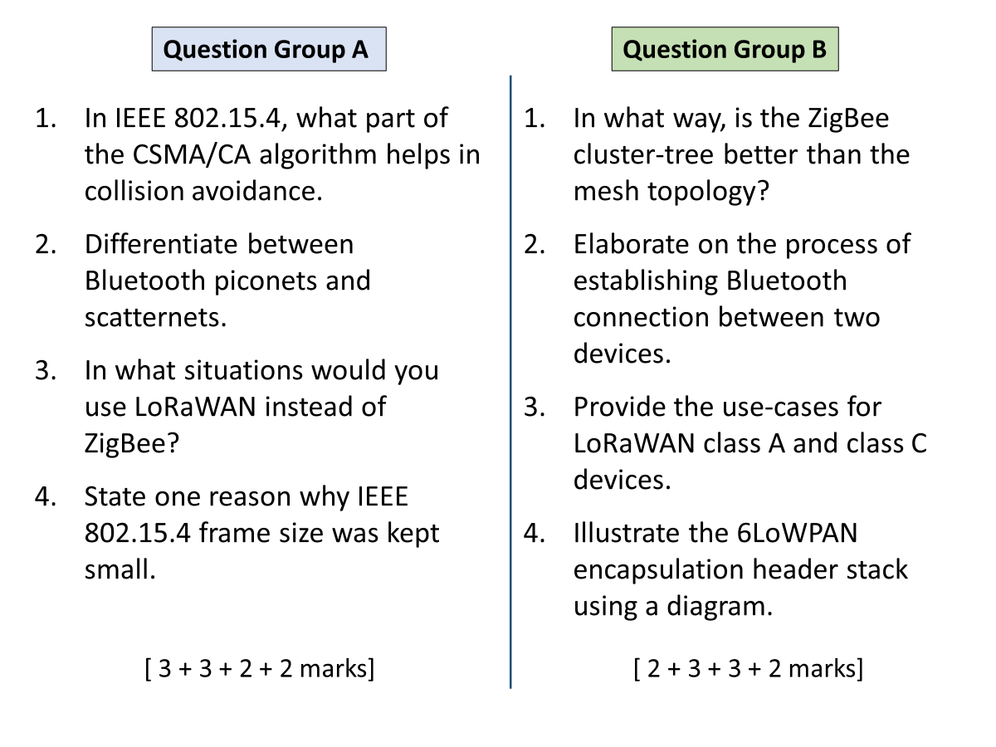

A

1

Specifically the backoff part – waiting a random amount of time reduces the chances of collision, coz each node picks its own random timer.

2

Piconet is one master connected to up to seven slaves. Master controls the piconet.

Scatternet is an interconnection of multiple piconets. A node joins two or more piconets and acts as a bridge for communication b/w piconets. That node can’t be master in both.

In scatternet, each piconet continues to operate independently.

3

When long distance connectivity for sensor nodes is required, data rates requirements are quite low, and prolonged battery life is important.

4

L12 slide 6

B

1

Cluster-tree is less expensive to set up, while still providing the advantage of coverage over a larger area.

2

L10, slide 9

3

Class A is to be used when a longer battery life is desired, but downlink latency is tolerable.

Class C devices are always listening, so these used when a real time action is expected (in response to a command from the server).

4

L12, slide 20